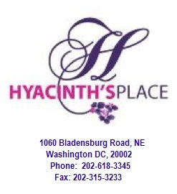

Volunteer Application Form

The Institute of Urban Living – Hyacinth’s Place project is a 501-c-3 non profit interested in recruiting volunteers to assist in the effective functioning of the agency. Please complete the application form and return to Urla Barrow at urla@hyacinths.org or 1060 Bladensburg Road. NE. Washington DC 20002.

Name: ______________________________________________________________________________
First initial last
Address: ______________________________________________________________________________
Number street Apt No., Unit No., P.O Box
______________________________________________________________________________
City/Town Postal Code:
Email: _______________________________ Occupation: ___________________________________

DOB: ___________________________Age: _________

Home #: ____________________ Cell #: _______________________

Position Applying For: (Check the applicable circle)
- One time volunteer
- Long term volunteer
- Unsure

Preferred Start Date: Area of Interest:
- ASAP ○ Fundraising/Development
- Date: ___________ ○ Information Technology ○ Administration
- Psychology/Therapeutic Groups
- Chef/Cook/Kitchen Helper
- Sign Language Interpreter
- Financial/Accounting

Why are you interested in volunteering?
________________________________________________________________________________________________________________________________________________________________________________________________________________________________________________________________________________________________________________________

How did you hear about Hyacinth’s Place Project and its volunteer program?
____________________________________________________________________________________________________________________________________________________________

List Any Previous or Current Volunteer Experience:
Organization Position/Major Responsibility Dates of service (yy/mm)
From: To:
1______________________________ _______________________________ __________________
2______________________________ _______________________________ __________________

How do you hope to benefit from this experience?
____________________________________________________________________________________________
____________________________________________________________________________________________
____________________________________________________________________________________________

What is your preferred method of contact?
- Via email
- Via phone

The Institute of Urban Living- Hyacinth’s Place would like to thank you for your expressed interested in helping Hyacinth’s Place fulfill its mission. We look forward to working with you and hope this will be a great experience for you!

Signature of Applicant Date

