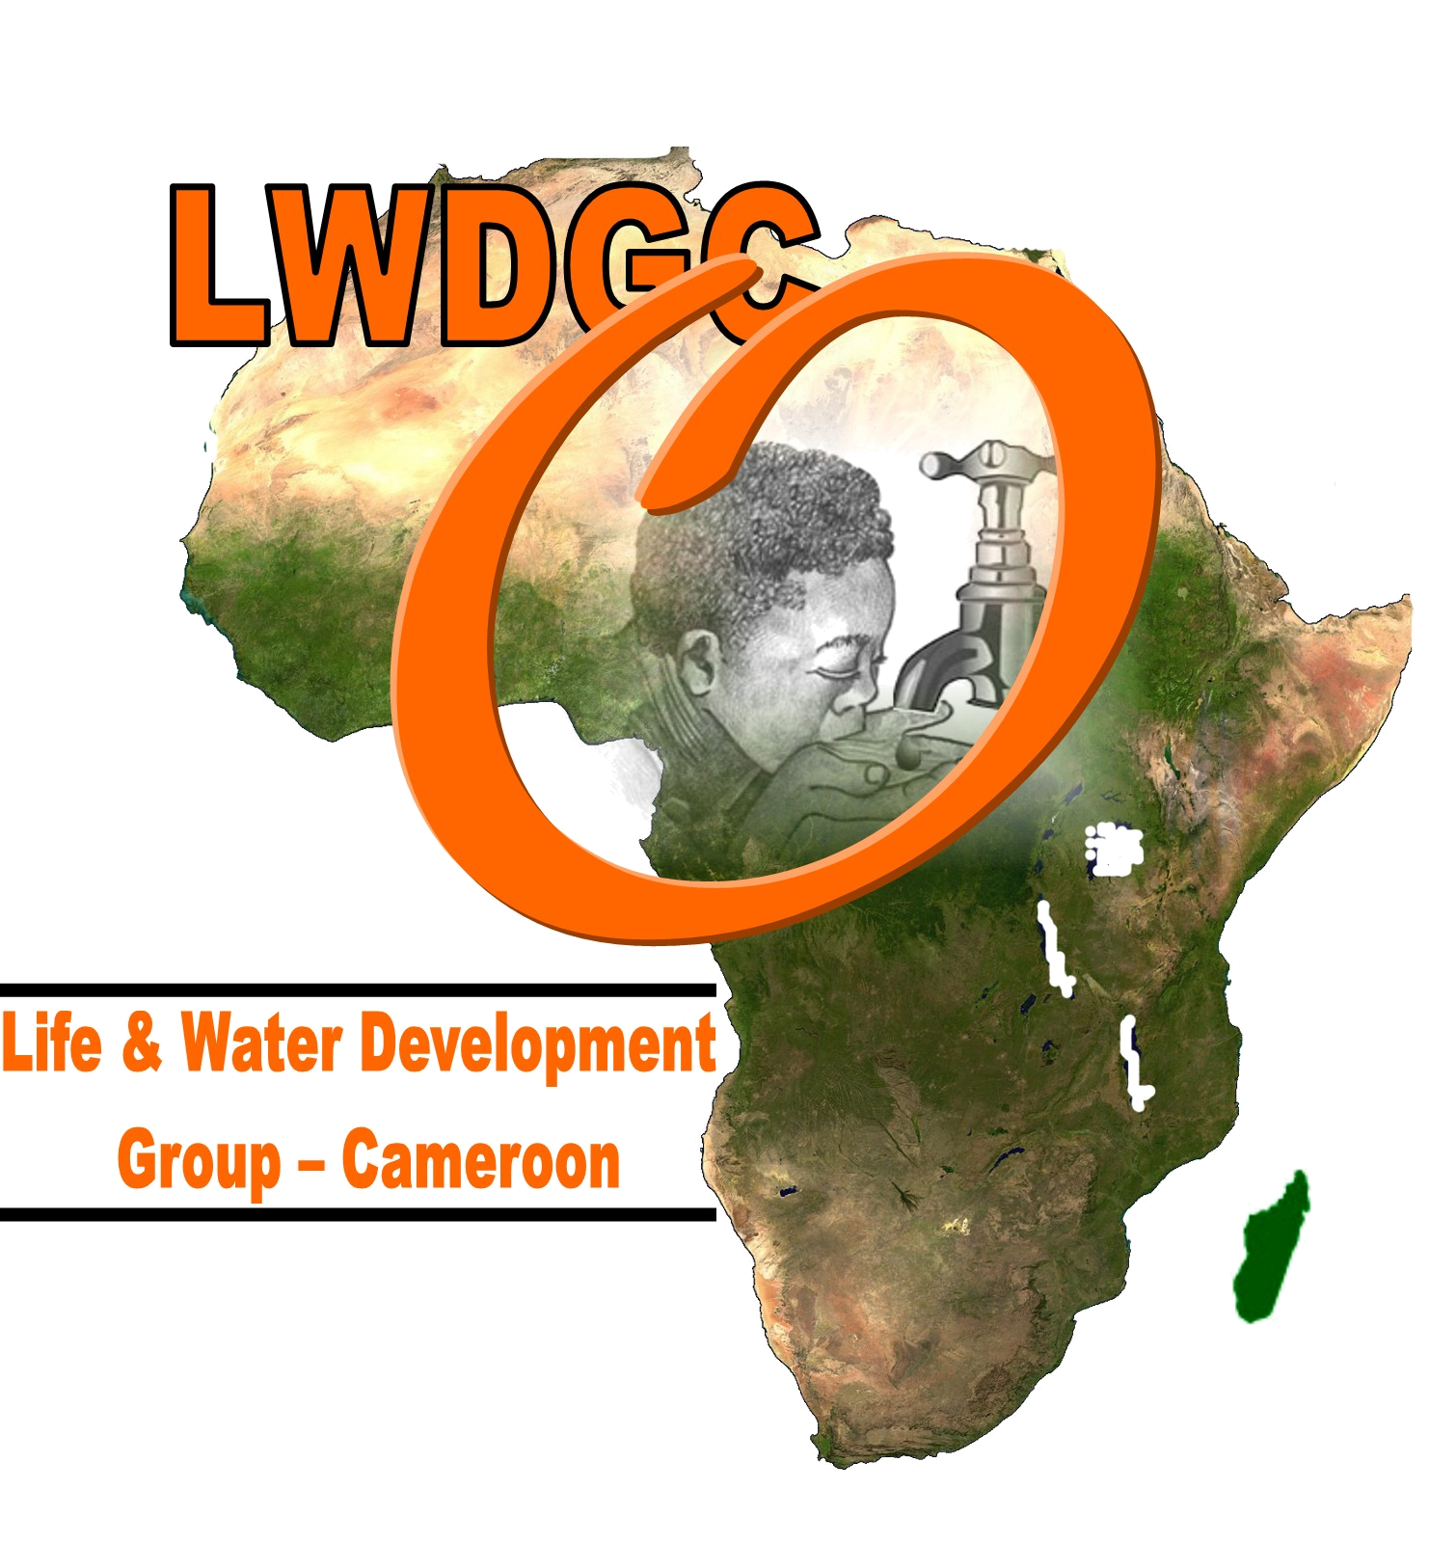

Together We Are Making a Difference, Changing Lives
Tel.: +237 77 71 62 88
E-mail: info@lwdgc-africa.org
Website: www.lwdgc-africa.org
Yaounde - Cameroon
REG. N°: CE/GP/23/06/18960

Life & Water Development Group – Cameroon

COMMUNITY SERVICES AND VOLUNTEER APPLICATION FORM

Background of organisation:

The Life and Water Development Group - Cameroon (LWDGC) is a non- governmental organization and a CIG with Reg. N°: CE/GP/23/06/18960 working in Cameroon since its inception in 2004, the organization has been working with local communities in the rural areas, children, youths, parents, and intergovernmental bodies in the promotion of issues related to the welfare and rights of the underprivileged people. It works to identify and remedy the needs of every community in every field, especially the underprivileged in the rural areas through a participatory approach.

LWDGC is also engaged in education and training in the areas of HIV/AIDS, youth leadership. Popular education thus forms part of its outreach strategies where such a facility would otherwise be unavailable to underprivileged communities, children, and youths in the target communities. This mobilization by LWDGC enables development to come along with community empowerment and social engagement by all concerned.

All of these issues are addressed through a series of programs and strategies, which aims at a sustainable contribution of LWDGC to development within the framework of the MDGs, and global employment frameworks.

AIMS:

LWDGC was created in response to:

- The rising rate of unemployed youths from professional and non-professionals schools.

- The high level of poverty that can be checked through self-employment and volunteer opportunities.

- Slow social development in the rural areas, and limited initiatives to control the situation.

- The realization that through voluntary work, a solution could be found to fill the gaps that cannot be filled by the public, corporate and private employment sectors.

- The underprivileged, uneducated and socially abandoned to prove their own worth to the society through their contributions as volunteers

Current projects:

Teaching nursery/primary and secondary children
Outdoor skills
Educating orphans children
Youth leadership training/workshop
Community Development Work
ICT training for rural youth
Arts& crafts
Health care/medical
Human Rights
Water for All
HIV/AIDS and Malaria Prevention

TYPES OF VOLUNTEER OPPORTUNITIES

- Students seeking internship.
- Unemployed graduates seeking professional experience
- Professionals that are yet to be employed
- Everyone with a zeal and feeling that they have something to offer to the development of the society (age, education, race, color and physical condition not a prerequisite)

Mission statement:
To learn about the ‘Volunteering Landscape’ of Cameroon and serve within an international context as the National Centre of Excellence to appreciate and maximize the positive impact of volunteering on individuals, groups, organisations, the community and society

Volunteer Benefits

In addition to the training for the required job, volunteers will receive:

- End of volunteer certificate to testify work ability.

Volunteer recruitment:

What skills are needed? No specify skill is required

How long volunteers can stay? Two month – Twelve months

Accommodation: Available at the Guest House (payable), Host families ‘

Volunteer Position: Unpaid

Volunteer’s Minimum Age Required: 19 years

Languages: English and French

Program Fee: No fees are charged but volunteers will pay their living cost. We estimate that
this will cost 300$+ per month = Includes food (2 meals a day), accommodation and water. Volunteer should have enough means of finance because we will not be incharge of his expenses like taxi fares, liesure travels, site seeing etc...

This Program is concerned with how:

- Our members can assist in other areas of the community without really thinking of compensation. Most often, many of our community projects are not able to afford for enough income to meet up with their expenditure. So they need some people with skills they require to assist them for free.

- International Volunteers: There are also avenues for international volunteers to come over to our center to assist us in our various projects.

Hence we try to promote the spirit of volunteering in our community so as to help those who cannot pay for benefit at least from knowledge and services we can render. So far, we have received so many volunteers from the US and Canada.

Below is more information about our volunteer different job opportunities and please chose those that are interesting to you and apply.

VOLUNTEER POSITIONS

Main Areas of Volunteer Intervention

Education:

LWDGC aims at working with the rural communities in being able to identify those schools in the rural areas that run short of teachers and institute a volunteer scheme for these schools to have teachers who volunteer for skill development and experience purposes.

We also encourage the introduction of life long learning centres to enable the older generation to be part of the learning process. That is adult literacy centres should become functional. We also advise on educational projects that can be good for our communities.

Health:

Many rural communities do not have enough health personnel while there are so many of them trained out there who do not have work. LWDGC works in close collaboration with some of these communities and is able to place health volunteers in these communities who with the aim of providing a lasting contribution to the sector in the relevant community.

Reproductive Health

We work with the young people, teaching them skills on how to grow up as responsible citizens with responsible sexual behaviour. We place volunteers in communities needy of this kind of youth education. Ideally, we work with primary and secondary schools with the aim of reaching the pupils and students who are the most vulnerable group to STDs.

- Avoiding unwanted pregnancies.
- Contracting sexually transmitted diseases.

Human Rights

Our starting point for human rights education is the young people whom we teach on the rights of the child as enshrined in the United Nations Convention on the Rights of the Child. Growing up as responsible citizens, forms the basis of our human rights education that we work on with the young people. Again, we work with schools towards the teaching of the fundamentals of human rights to young people.
Community Development Projects:

We have community development projects like water projects, construction of health centres, nursery and primary schools, bridge constructions, community hall construction, orphanage centre constructions, library supplies, computer and internet centre supplies etc…

HIV/AIDS

- We work with the community to give them to live healthy lives void of HIV/AIDS.
- We also work with other community organisation to help AIDS Orphans in the basic needs (school fees, books, uniform).
- We also offer assistance to those who are not enrolled in school to pay for their vocational training in areas like; dressmaking, auto-mechanics, carpentry, masonry.
- We work with people living with the HIV/AIDS virus to live healthy and happy lives.

ICT:

With the constant evolution ICTs and especially with the arrival of the internet as a major tool for communication and other new developments in the computer age, many are still lagging behind and need to be part and parcel of the development.

SUSTAINABLE LIVELIHOOD ACTIVITIES

LWDGC seeks to offer the opportunity to the underprivileged and women groups to have means to start small enterprises that can enable them to have something to live on.

We encourage and support the setting up of petty trades of the applicant’s choice. (They include; mixed farming, sales of household items, and other lucrative business ideas from volunteer applicants.

- TEACHING: in Nursery, Primary, Secondary School, Vocational School in a rural areas. Here we have many partner schools in need of volunteer teachers to assist them. These are community-managed schools with little resources to pay staffs. Hence, volunteers are highly welcomed for at least 3 months+ teaching. You live in the village with the community. You can teach interesting subjects to schoolchildren and even to the community. Let us know which classes you can handle well.

- NKUV HEALTH CENTER REHABILIATION: Here we need people to help us rehabilitate a health center that has been abandoned by the government; the local commuinty is finding it very difficult to rehabilitate this health center because of lack of finance and equipment. We would like to have health volunteers who can help bring back this health center to life and manage it for the community. The community lost so many of its population, especially children under five, because of lack of closer medical attention. Pregnant women deliver their children on the way hiking to the nearest city, some of these women have their babies on the way, and some lost their babies because of tiredness and hard labor without any healthcare. Patients die in this community because they lack medical care, some die on their way up the hills hiking etc… If we can have some volunteers who can renew this health center and equipe it with the medical equipment to be able to recieve and treat the patients, we would be very happy. We need nurses, doctors, and other health practitioners as volunteers interested in health domain to work in this health and other health centers in other communities.. He/she shall live there and feeding is subsidizes. We would also like to have a training program for nurses, you can teach there.

- Nkuv Community Hall Construction: The community of Nkuv seek volunteers to help them construct their local community hall where they can come together and organize their community activities.

- Nkuv Women Association Group needs a volunteer to help them setup a micro-enterprise business to sustain families, underprivileged, orphans and disable children in the community.

- COMMUNITY WORKS: HIV/AIDS EDUCATOR position is also available for anybody to who can assist us manage our HIV/AIDS school programs and HIV/AIDS community education schemes. Give health talks to students, show video, try to organize the various groups.

- Orphanage Center Construction: The population of Kumbo and Nkuv seek volunteers to help them setup an orphanage center where they can house orphans from all of the two communities and other towns and villages around their localities. Presently, they have more than 2000 orphans living in very bad conditions in host families that do not take good care of these orphans. They want the center to have other activities like computer center, clinic and a library where children can read and have their medical treatment.

- PROGRAMS ASSISTANT:
  - Here we need somebody to assist us work in maintaining our field programs & partners and supervising our extension works.
  - She/he works most often in the field linking our partners.
  - Help us write projects and do fundraising packages/events.

- AGRICULTURAL EXPERT
- Agricultural expert teach the farmers better ways of crop production so as to have more yield and even more techniques to store their products.

- ORPHANAGE PROGRAMME
- Our NGOs are running an orphanage programme, volunteers willing to help sponsor our orphans in their education, training programs should contact us immediately. Our Orphanage programme is either by an individual volunteer or group of volunteers. We have volunteers that are sponsoring our orphan children by sponsoring their entire education, training programs. We have not created an orphanage center as of now, and we would also welcome volunteer(s) who are willing to help us build an orphanage home. We have more than 2000 orphans in Bui Division, and they are still staying in guidance’s homes, standard of living is not comfortable for most of our orphans, so we really would be happy to have a home for these children.

- WATER PROJECTS
- Water projects, our communities still lack portable drinkable water and we would be very happy to have some volunteers who can help our communities realize some water projects to enable them have good drinking water. Currently, we have bio sand filter project included in our water project program and we would like to have volunteers who can help us construct more bio sand filters and sensitize many communities to be using these filters because the result we had from the previous 30 filters is very positive and many families have had improved health from it.

WHAT WE CAN OFFER:

- Volunteers will stay with host families or stay at the hotel on his/her charges if chosen a hotel
- We pick you up from Airport if required. ETC

USEFUL INFORMATION TO ALL VOLUNTEERS:
- The Living cost in our community is about 300+ U.S dollars per month.
- Life is very natural here and from April to September, we have rainy season with heavy rainfalls and from October to March, dry season with heavy sunshine.
- Generally, the weather is very cold during the mornings and evening periods. So you need much hot wears.
- Our various structures lack adequate work and training materials. So please come along with enough training materials to teach or make your work have some impact on the community when you work.
- You might need to donate financially or in kind when you come. So be prepared to assist the people where you are.
- You might be working in certain rural areas with poor transportation means. Therefore, you might need to bring a car if you can afford sparing one.
- You need to bring your lab top computer if you have.
Traveling from your home country to Cameroon is a great opportunity to bring some essential items that could mean so much to the community you will be working in. After you arrive, the chances of receiving supplies diminish due to import duties and corruption in the postal service. Bringing items with you when you come can ensure that your donation will definitely get to the people who really need it.
If you are considering posting or sending supplies please check with LWDGC first, as there may be ways to ensure your goods reach their destination intact and without fees.
WHAT VOLUNTEERS CAN BRING:
- The Children and schools love and need toys, paper, chalk, paints, crayons, markers, colored paper, coloring books, glue, children stories and other things that children in a nursery school setting might enjoy. Books for children in primary school, sign language books and videos, art supplies and sports equipment.
Supplies always needed in the LWDGC’s office:
- Computer supplies such as: Laptops, printers, mouse, diskettes, USB port/flash memory devices, ink cartridge
- General office supplies such as: pens, pencils, staples, paperclips, notepads, highlighters/markers
Ideas for gifts for friends/students or LWDGC staff members:
- Cell phones that can use a SIM-card. They can be given to friends or sold to provide money for the community.
- Calculators
- Pens, pencils
- Digital Cameras/Camcorders/Video Cameras for video and picture documentary programs for our training and Organization.
- Toiletries such as toothbrushes, toothpaste, soap, etc.
- Games (such as playing cards) or toys
- Books of any kind
NOTICE TO ALL VOLUNTEERS

- The Life & Water Development Group - Cameroon, wish to put before your notice some comments and rules we wish our volunteers to follow when they join our family.
- The Life & Water Development Group - Cameroon, disclaims responsibility or liability to any volunteer who travels out of Bui Division for non-official purposes.
- We also disclaim responsibility of any volunteer who is hurt moving in the streets after 9pm.
- We disclaim responsibility of any volunteer who happens to be injured while performing an immoral activity.
- The organisation request that for it’s public image, volunteers should withdraw from drinking above limits; avoid public boyfriend or girlfriend manifestation; dancing in pubs; and other negative social activities for our town has a high social conduct and despise public shows.
- Visitors are not allowed into the individual rooms for security purposes.
- All the volunteers should please notify the office in case they wish to travel out of town even during their free periods.
- Working hours from Monday to Friday range from 8.30am to 4 pm with 1 hour break time. Weekends are optional or upon request.
- Careful use of the organisation’s facilities shall highly be appreciated.
- Volunteer’s in country transportation fare is covered by the volunteer, especially during the site seeing and liesure time.
Please, Fill out the Application Form below and Send to us as Attachments so that we can Study and Evaluate. Send it along with your Curriculum Vitae and a clear Picture of yourself.

VOLUNTEER APPLICATION FORM

LIFE & WATER DEVELOPMENT GROUP – CAMEROON (NGO) in partnership with CAPEC | FOR OFFICE USE ONLY
Address: | Applicant’s Name:
P.O. Box 20646 | Enclosed documents: | Curriculum Vitae  Photo 
Yaounde - Cameroon | Comments:
Center Province  Cameroon | Interview:
Tel: (237) 77 71 62 88 | Accept/Reject:
Email: info@lwdgc-africa.org  Website : www.lwdgc-africa.org | Sign:

APPLICATION FORM

Please Type or use CAPITAL letters and write legibly. If necessary, attach an extra sheet.

A | INFORMATION ON THE APPLICANT:
1 | NAME:
2 | SEX:
3 | HEIGHT:
4 | AGE:
5 | NATIONALITY:
6 | WORKING LANGUAGES (Specify all your working languages by writing Yes or No):
 |  |  | English: French: Others:
7 | HIGHEST QUALIFICATION:
8 | MAIN PROFESSION or OCCUPATION:
9 | SKILLS: |  | Please list below your skills, whether academic or working.
B | CONTACT INFORMATION:
 | Please note that all correspondences will be sent to this address; So make sure it is correct.
1 | POSTAL ADDRESS (Street, Number, City, Postal code, Country):
2 | TELEPHONE:
3 | TELEFAX:
4 | MOBILE PHONE:
5 | EMAIL:
C | INFORMATION ON THE SENDING ORGANIZATION/ INSTITUTION (if any):
1 | POSTAL ADDRESS:
2 | TELEPHONE:
3 | TELEFAX:
4 | EMAIL:
5 | WEBSITE ADDRESS:
6 | DESCRIBE THE SCOPE AND MAIN ACTIVITIES OF THE ORGANIZATION:
7 | What is your function or role in the organization?
D | EXPERIENCE AS A VOLUNTEER:
1 | Describe any volunteer experiences you have had before.
2 | What type of training have you received before in youth work or organisational work?
3 | Have you been involved in any other activity or project within your country?  If yes, which one(s)?
E | MOTIVATIONS AND EXPECTATIONS:
1 | In which Volunteering Opportunity are you interested?
2 | What are your Motivations and Reasons for wanting to take part in this internship
3 | Your volunteer needs: what would you like or do you need to learn on this internship?
4 | Follow-up and implementation: In which ways do you expect to be active in volunteering after working with us? What will your target group be?
5 | Outcome of your participation: In which ways do you think your participation will contribute to the implementation of programmes for rural development where you shall work?
F | PLEASE PROVIDE THE CONTACT INFORMATION OF TWO PEOPLE WE CAN CONTACT FOR REFERENCES:
1 | Name:
 | Title:
 | Relationship with you:
 | Address:
 | Telephone:
 | Telefax:
 | Mobile Telephone:
 | Email:
2 | Name:
 | Title:
 | Relationship with you:
 | Address:
 | Telephone:
 | Telefax:
 | Mobile Telephone:
 | Email:
G | PRACTICAL INFORMATION:
1 | Special needs: Have you any special needs or requirements or assistance that you want the organisation to take into account (disability, dietary, logistics, travelling etc)?
2 | WHEN DO YOU INTEND TO START THIS JOB?
3 | WHEN DO YOU INTEND TO END YOUR JOB?
4 | VISA: Will you require visa assistance in coming to Cameroon? If yes, please indicate:
 | Your date of birth:
 | Passport Number:
 | Issued at (place):
 | Date of issue:
 | Date of expiry:

Please send your application by e-mail to: info@lwdgc-africa.org

DATE: SIGNATURE:

