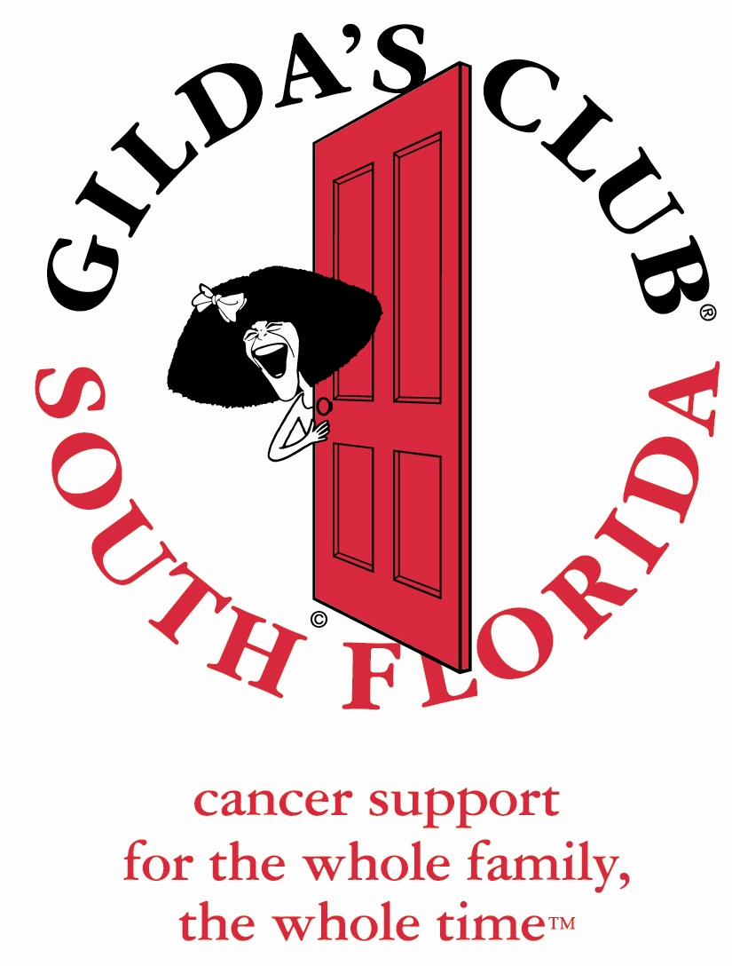

I’m thrilled that you are interested in volunteering with Gilda's Club South Florida. As you may know, we are the recognized leader in social and emotional support and education for anyone touched by cancer. Our family-centered programs reflect our philosophy that when cancer happens, it happens to the entire family.

There are many ways for you to share your time and talents. We have a wide variety of volunteer opportunities from which to choose. You can help out at the office, provide outreach to the community, or find fulfillment in many other ways.

Our clubhouse is located in downtown Fort Lauderdale, in a historic home along the Tarpon River. At Gilda’s Club, those learning to live with cancer gather for support groups, lectures, and fun social events. Each month, there are at least 60 activities offered—always free.

Please take a moment to complete and return the enclosed application. The application must be received by us before you can take part in a volunteer orientation. Orientation meetings are held regularly at the main clubhouse. You will receive a telephone call in order to schedule your attendance at the next orientation.

Thank you again. I look forward to hearing from you.

Warm regards,

Lisa Zucker
Volunteer & Outreach Manager
Lisa@gildasclubsouthflorida.org


Gilda’s Club South Florida
Volunteer Opportunities

Special Events
These may include a fundraiser event, an Ask the Expert lecture, or other special workshops or conferences. Volunteers are needed before, during, and after the event. Event participation may last for up to 6 hours. Other volunteer duties include setting up and cleaning up, registering members, moving furniture, helping to decorate the clubhouse, etc.

Social Events
These fun events are held at Gilda's Club South Florida. They include Joke Fests, Pot Luck Suppers, Movie Nights etc. Volunteers are needed before, during, and after the event. Event participation may last for up to 6 hours. Other volunteer duties include setting up and cleaning up, registering members, moving furniture, helping to decorate the clubhouse, etc.

Clubhouse Support
This is a very important position as it helps us keep the clubhouse running smoothly. Computer knowledge is helpful but not necessary. Any amount of time volunteered is helpful. Other volunteer duties include data entry, answering phones, making phone calls, stuffing envelopes, etc.

Outreach
This position involves travel. You may be asked to drop off calendars or invite healthcare professionals to special events at the clubhouse. These volunteers work closely with the Outreach Coordinator. You can volunteer your time for the entire event, which may be 8 hours or you can split the shift. Other volunteer duties include manning booths at health fairs, conferences, or at educational seminars.

Noogieland
This position involves working with the children and teens. You may assist with activities such as Teen Nights, Noogiefest, Birthday Bash, or our Spring Fling. Other volunteer duties include setting up and cleaning up, registering members, moving furniture, helping to decorate the clubhouse, etc. Event participation may last for up to 6 hours.
A background check is required.

Gilda’s Club South Florida
Volunteer Application Form

Date:

Name:

Address:

Email:

Phone Number: **please provide the most convenient number**

Place of Employment / Name of School:

Previous Volunteer Experience:

Please list two references.
Name: Phone number:
Length of Time Known: Relationship:
Name: Phone number:
Length of Time Known: Relationship:

Why are you interested in volunteering at Gilda’s Club and how did you hear about us?

Any hobbies or special talents?

Areas of Interest: Please Highlight ALL that apply.

Special Events Social Events Clubhouse Support Outreach Noogieland

Staff Use Only:
Volunteer Orientation Date & Time:________________________________ Volunteer Approval: Y N

Background Check Complete: Y N Member: Y N Other: __________________________________

