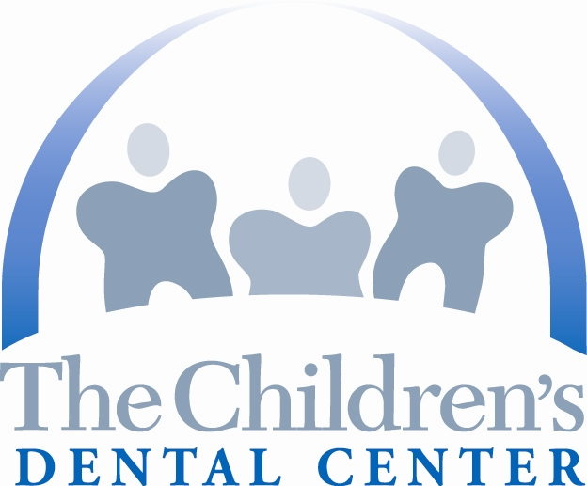
THE CHILDREN’S DENTAL CENTER

Toothfairy Cottage Educational Center

We need volunteer dentists, hygienists, assistants, nutritionists, students and other support personnel to join with TCDC staff to provide oral health prevention, education and treatment to children and parents.

Can you join us? For more information, contact Tara Bultema, Outreach Director, at 310-419-3000 x 208 or tbultema@tcdc.org.

* * * * * * * * * * * * * * * * * * * * * * * * * * * * * * * * * * * * * * * * * * *
VOLUNTEER REGISTRATION

Name _________________________________________________________
First Last

Address _______________________________________________________
Street City Zip

Phones ________________________________________________________
Work Home Cell

Fax _________________Email _____________________________________

I am a (check one):
❑ dentist  hygienist  assistant  student  other_____________

I am available (check one):
❑ all day  8-12  12:30-4  2-4  other ____________

I am available (circle all that apply):
Monday Tuesday Wednesday Thursday Friday Saturday Sunday

Comments:______________________________________________________

SUBMIT COMPLETED FORM TO:
Tara Bultema, Outreach Director, Fax 310-677-3087 or email tbultema@tcdc.org

Thank you for your interest in volunteering!

