STUDENTS PARTNERSHIP WORLDWIDE

APPLICATION FORM FOR OVERSEAS PLACEMENT – Americas

This will be sent to the Director of your placement overseas, please print clearly
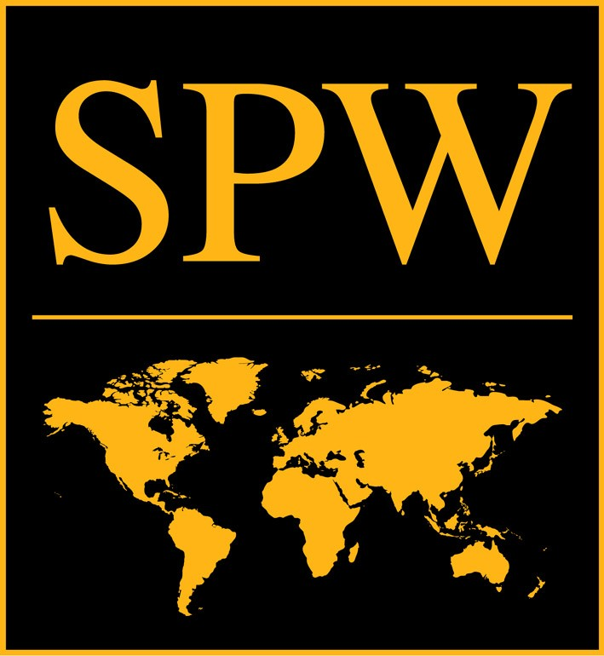

Attach a recent
passport photo
OFFICE USE ONLY
Electronic -
Paper -
App Fee -
Refs Received -
Accepted -
Selection -
To apply, please:
1.Complete this form in this format.
2. Email it as an attachment to volunteers@spw-usa.org
3. Mail this form and a $40 check or money order (application fee) made payable to SPW USA to:

SPW USA, 1413 K Street NW, 5th Floor

Washington DC, 20005

Canadian Residents: We regret that we are unable to process Canadian checks. Please send a money order in USD.

1. PERSONAL DETAILS
Full Name (as stated on your passport)
Preferred name
Permanent address |  | Second (school) address and applicable dates
Telephone |  | Cell Phone
Email
Date of Birth |  | Place of Birth
Country of Citizenship
Next of Kin (Emergency Contact)
Next of Kin Address

Next of Kin telephone (day and cell phone) |  | Next of Kin email
Do you have a Passport? | Passport Issue Date |  | Passport Expiration Date

2. HEALTH INFORMATION
An offer onto an SPW program is subject to a health screening with an independent organization which may contact your doctor for more information. More information about this will be given if you are selected onto a program. However, please tell us now any specific requirements you may have, so that we may be able to accommodate these while you are overseas.

Do you have any needs which require particular practical support or accommodation? (Such as: refrigerator for medication) If so, please specify:

3. CRIMINAL CONVICTIONS
Criminal convictions can have a bearing on your eligibility to obtain a visa to work in a different country.
Have you been convicted of a criminal offense in the last 5 years? Yes No

Do you have any criminal proceedings pending? Yes No

If so, please supply details –

4. EDUCATION (please start with the most recent)
Name of Institute | Dates Attended | Qualification and results

5. VOLUNTARY AND PAID WORK EXPERIENCE (please start with the most recent)
Name of Organization/Employer | From – To | Voluntary/paid | Position held and description of main duties and responsibilities

6. PROGRAM APPLYING FOR
Please decide which program you wish to apply for and ensure that you are available for the whole program. Check www.spw-usa.org or contact the US office at 202.289.0914 for dates.
What academic year are you applying for? (eg. 08/09 or 09/10) –
Choice of Country and Program – please state a first and a second choice (eg. India HEP and Zambia TAAP):
Choice 1
Choice 2

7. RECRUITMENT MONITORING

What is the date of the information session conference call you attended or you plan to attend?

Please tell us how you heard about volunteering with SPW. This will help us assess our various recruitment initiatives. Please check all that apply.

Google
Idealist.org
Internet (please indicate the specific site or search engine)
SPW recruitment event
SPW returned volunteer
SPW staff member
University fair (please indicate which fair or university)
University/school talk
Other organizations
Directory/book (please indicate which title)
Newspaper article
TV /Radio
Family/friend
Other (please state)

8. SUPPORTING INFORMATION FOR YOUR APPLICATION TO SPW (Feel free to continue on a second page)

Please describe your reasons for wanting to volunteer overseas.
What specifically about SPW’s programs interests you?
In what ways do you think you can contribute to the work of SPW?

9. REFERENCES
Please give details (including email address!) of two people SPW can contact – preferably ONE teacher or employer and ONE other adult (not one of your peers) outside the family and not connected with the school, university or work, who know you well and are willing to provide a reference.
Name | Name
Email | Email
Tel | Tel
Relationship to you | Relationship to you

Signature ______________________________________ Date __________________________

