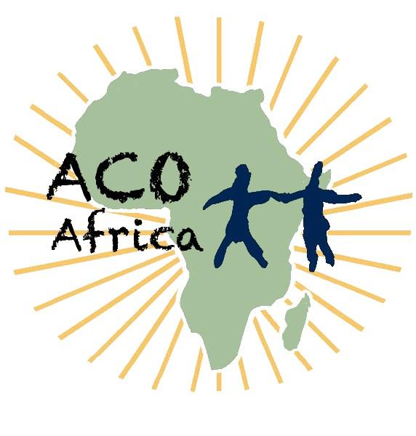
Abaana Community Outreach Africa
Volunteer Application Form
To apply for the position, please fill in your details. Send the completed form to johnbosco.acoafrica@gmail.com
1.Personal information
Last name: |  | Date of birth (dd/mm/yy):
First name(s): |  | Gender:
Citizenship: |  | Country of residence:
Contact phone: |  | Email:
Address: |  | Street/City:

2.Background
Education:
Specialisation: |  | Languages:
Occupation: |  | Languages:
Personal interests

3. Volunteer placement

when do you plan to stay in Uganda | From (dd/mm/yy): |  |  |  | To (dd/mm/yy):
Which of ACO-Africa's activities interests you the most?  (Choose one or more activities) | Community Work |  |  |  | Human Rights
 | Food and Nutritional Care |  |  |  | Health Care (community health outreach clinics and HIV care)
 | Economic Empowerment |  |  |  | Psychosocial Care
 | Education/Teaching  Please specify subject(s): |  |  |  | others (Specify)
What are the motivations of your stay?
What do you expect to gain from your volunteer placement?
What do you expect from ACO-Africa?
What do you expect to contribute to the vulnerable communities
4.Emergency contact

Last name: |  |  | Relationship:
First name (s): |  |  | Contact phone:
5. Signature

Your signature confirms:

- You are genuinely interested in helping the most poor and vulnerable communities of Uganda.
- You have read and are familiar with the "Abaana Community Outreach Africa (ACO-Africa) Terms of Volunteering".
- You are medically fit for field work in rural areas of Uganda.
- You intend to do all the necessary preparations required for your stay.
- The information you have given is accurate and complete.

Signature: ______ __ Date (dd/mm/yy):

