Be a Volunteer!
Dirección: Jirón Buenos Aires N° 201 - Barrio la Florida / Cajamarca - Perú
Teléfono: +51 -76 - 366234 Celular: +51 976331474
Correo: letsgoperucax@gmail.com / carlosvaleraromero@gmail.com

BE VOLUNTEER IN ASIKUQ ANTINAKUNA NGO.
What means a volunteering service for us?

Our program is located in the city of Cajamarca, the most important of the northern highlands of Peru, located at 2750 meters above sea level on the eastern slopes of the Andes, in an Inter-Andean valley. Cajamarca was considered one of the most important metropolis of the Inca empire. Where was the scene of one of the most important events in Latin American history and even of universal history : The meeting of Two Worlds.

This Volunteer program offers stays from 03 months, 06 months, 12 months or determined by the volunteers and the sending organization. A volunteer (man or woman) from 18 years and no age limit, supports us in one of the work areas: poverty, social inequality, education, public health, gender equality, cultural identity, Quechua language, natural resources and the environment. Volunteer work, is funded by the sending organization , maybe independent or part of government of the origin country, prior agreement with the partner organization.
The goals and impacts of the volunteer program?

We work so that the strong social commitment of volunteers, is aimed at achieving mutual learning based on direct experiences in rural and marginal urban realities, where mainly we foster environments of peace and respect committed to integral development. Thereby we seek to show and spread the true socio-economic reality of our region, involving volunteers in projects that we manage.

We provide unwavering support for the Volunteer program, from a motivating and supportive position to understand that cultures have different ways of thinking and acting. To do so consistently we provide support in the language and the Peruvian culture, as we believe that these elements are essential for adaptation and full development of the Volunteer.

We develop our post-volunteer program supporting our ex volunteers to continue managing social development project anywhere in our region, supported by their sending organizations and involved governmental entities.

With this program we mainly seek the global twinning of involved organizations in social development, strategic alliances,that seek to share successful experiences and work together in social development projects to benefit vulnerable groups in Latin America.

Terms and Conditions of Volunteer Program

REQUIREMENTS:

1. Over 18 years with no age limit.
2. Proven mental and physical health (indispensable
medical documents).
3. Indispensable basic knowledge of Spanish language (foreigners).
4. Indispensable residence permits and legal documents in current rule (foreigners)
5. Indispensable strong social commitment and adapt to living conditions in the countryside.

TEMPORALITY

Our volunteer program provides residence times from 03 months, 06 months, 12 months or determined time by the volunteer.

PERIOD | 03 MONTHS | 06 MONTHS | 12 MONTHS | MORE THAN 12 MONTHS

Volunteers will be provided a personalized guide about the respective projects that we manage; besides having a companion or mentor who would provide ongoing support to become familiar with the project achieving productive cooperation for both parties.

AREAS AND WORKING TIME

Volunteers can work in communities in these development sectors.

Volunteering for strengthening and development of rural economic .
Volunteering for strengthening and development of rural education system.
Volunteering for strengthening and development of Rural Health System
Volunteering for strengthening and development of Folklore and cultural identity
Volunteering for strengthening and development of natural resource management.

- It Works full time, with two days off per week. Vacation time is agreed by the sending organization and the host.

FREE TIME

Volunteers work five days per week and receive two days off.

WE HAVE MANY ALTERNATIVES OF RELAXATION AND FUN, TOURISM, TRAVEL, LEISURE, CULTURE, FOOD, ETC.
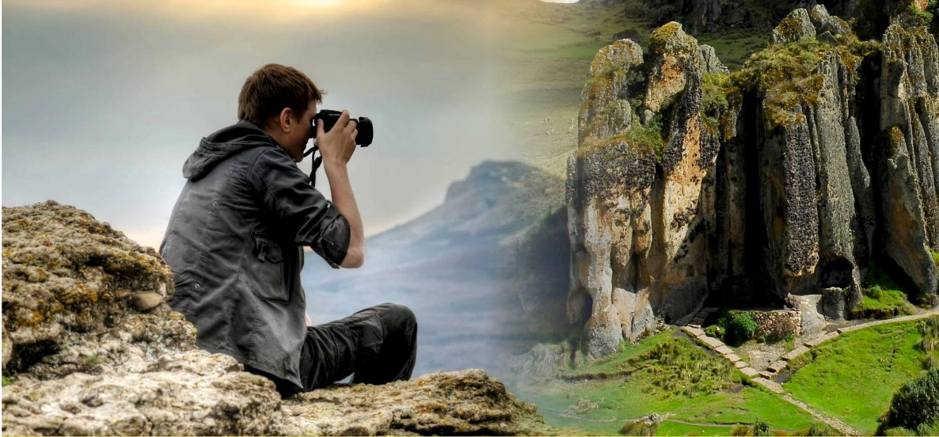

WHAT WE OFFER: 350$/month for person.

Accommodation and feeding
The accommodation is completely safe in our house Project. We have all the services. It provide to our volunteers the means for their peaceful rest, it is recommended to bring a sleeping bag and clothes for cold places. At arrival of our volunteers we will provide them our coexistence manual.
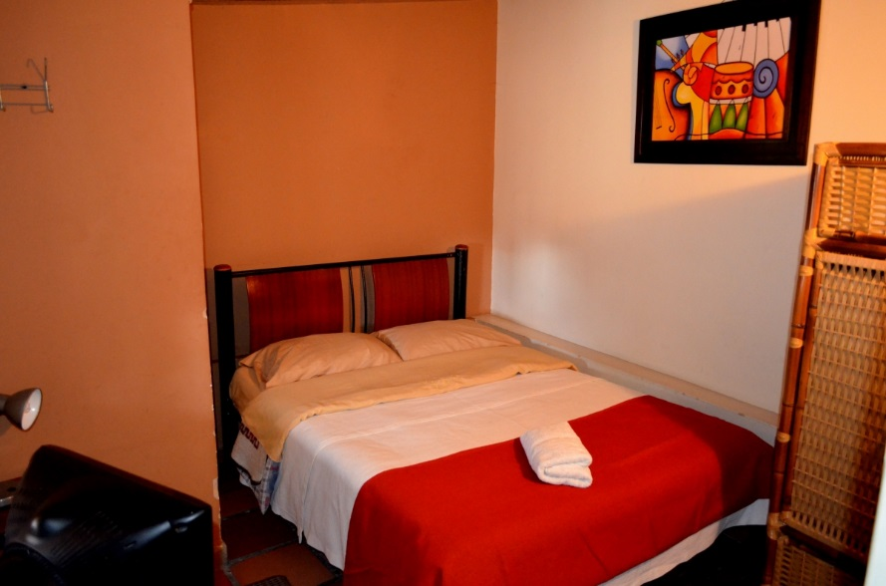

IMPORTANT: The feeding of our Volunteers is totally organic, we care about their physical and psychological care, constantly monitoring them. One meal a day
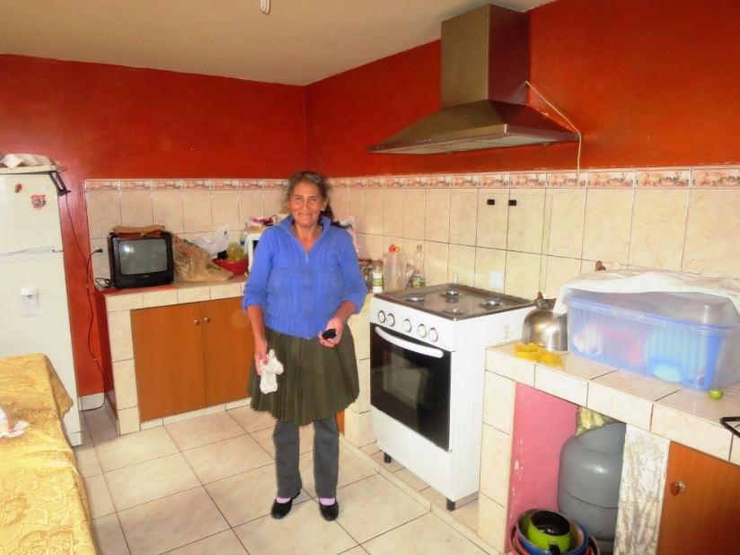

Note: Part of the proceeds from our kitchen serve to support the family of Ms. Tonita, a lady of poor conditions that we support with employment in our house, she helps us in preparing our food with a lot of cleaning, dedication and care.

Monitoring and continuous support

We provide tracing and continuous support, from the arrival of the Volunteer on our project, throughout the process of Volunteering and to completion, covering all their needs and concerns.

Certificate of completion of the Volunteering:

We grant formal certificate at end the process of Volunteering.

CONTACTS:

Address: Jirón Buenos Aires N° 201 – Neighborhood: la Florida / Cajamarca - Perú
Phone: +51 -76 - 366234 CellPhone: 976331474
Correo: letsgoperucax@gmail.com / carlosvaleraromero@gmail.com
FACEBOOK: https://www.facebook.com/ASIKUQANTINAKUNA

HOW TO GET:
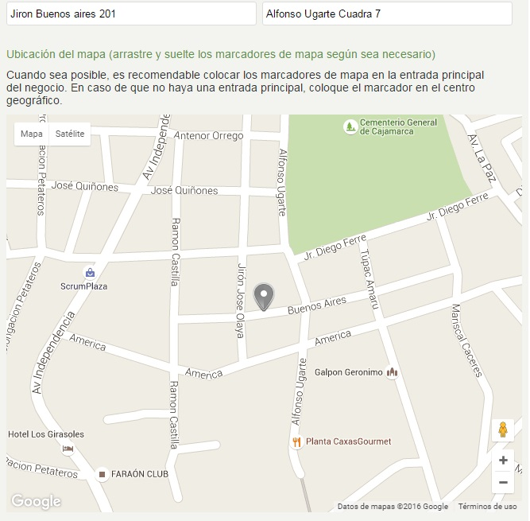

ONG ASIKUQ ANTINAKUNA

